
“Teterboro” Airport,399 Industrial Ave. Teterboro,NJ 07608 Phone (347)245-5143 Fax(718)727-3350 www.aeroteamny.com email: flysamolet@gmail.com
AEROTEAM LLC

BELL 47 SUPERG 235HP
PRICE: $112,000.00 SPECIAL BONUS: INCLUDED - CARGO POD AND CARGO RACKS
FRESH AUGUST 2013 ANNUAL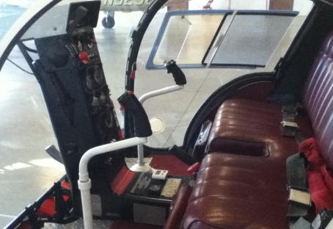
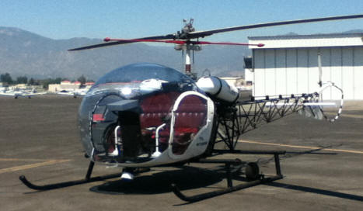

TTAF : 2723 hrs, TTSMO : 577.2 FRANKLIN 235HP COMPRESSION: CY 1=77 #2=78 #3=78 #4=76 #5=79 #6=75
Here are some specs provided by owner; (PLEASE BE AWARE HELO IS FLOWN REGULARLY)
.5 hrs on rebuilt T/R gearbox,
150.2 hrs on new stab bar,
150.2 hrs on new -23 gimbal ring,
150.2 hrs on refurbished -50 wood M/R blades,
150.2 hrs on new T/R guard,
150.2 hrs on o/h Bendix Magnetos,
.5 hrs on new FULL Ignition/ Sparkplug harness,
150.2 hrs on O/H MA -4-5 Carb,
150.2 hrs on O/H generator,
150.2 hrs O/H Clutch Assembly,
222.5 hrs left on grips,
100 hrs left on 600 hr affordable intermediate tail rotor blades
150.2 hrs on 600 Series Transmission.
avionics recently yellow tagged

EXCELLENT FIRST 3 PASSENGER HELO
LOGBOOKS & RECORDS
HELO FORMERLY OWNED BY AVIATION LEGEND DR. CARROLL VOSS

DUAL CONTROLS FOR INSTRUCTION
"BRAVO" N #
LANDING LIGHT WITH SHROUD

GREAT PERFORMANCE, USEFUL LOAD, AND RANGE

EXCELLENT COSMETICS AND DECALS INCLUDING "THE BELL BUBBBLE LOGO"

CARGO SKIDS WITH GROUND WHEELS

OWN AN AUTHENTIC LEGEND "THE WHIRLYBIRD"

