CAMLOC СЕРИИ 2600
Receptacles V212-12-2FGV
D=3,3. Hard Bronze/zinc-plated, CrVIfree, transparent passivated
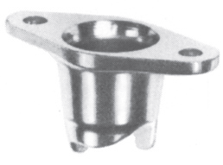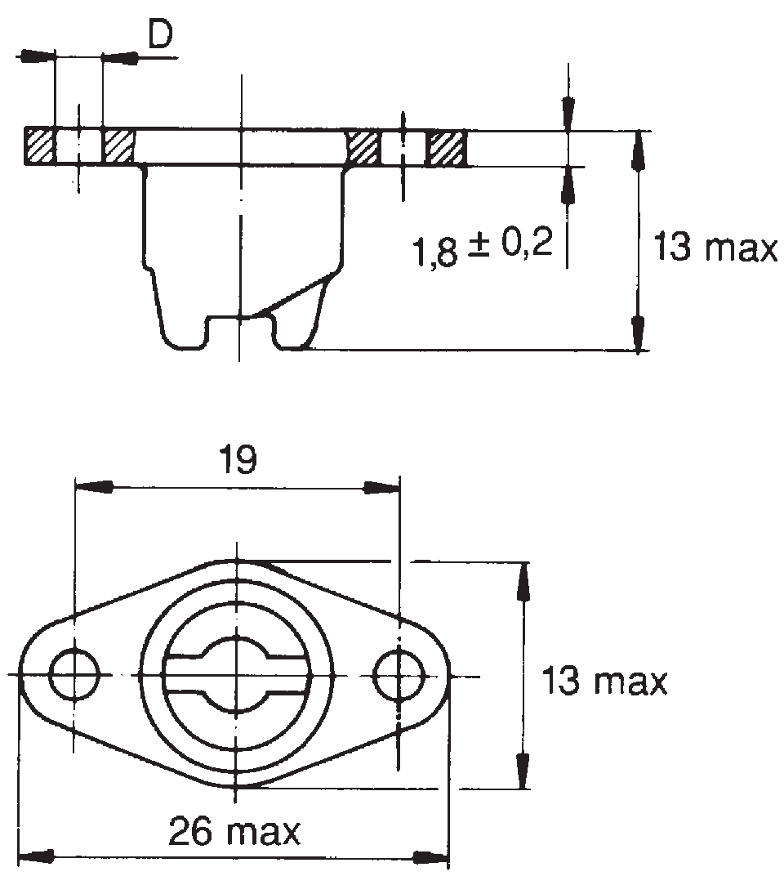

V26R6-1AGV
D=2,6. Steel/zinc-plated, CrVI-free, transparent passivated


